Chapter 11, Problem 19.

The variable resistor R in the circuit of Fig. 11.50 is adjusted until it absorbs the maximum average power. Find R and the maximum average power absorbed.

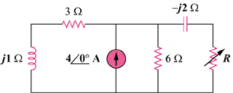

33∠0˚A

Figure 11.50
For Prob. 11.19.

